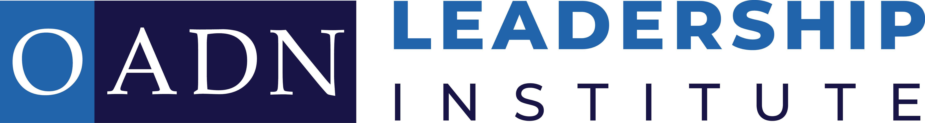
APPLICATION

First Name: Last Name:

Credentials: Current Position:

OADN Member:
- Yes
- No

Current Employer:

Employer City & State: Preferred Mailing Address: ___Home ___Work

Address:

City: State/Territory/Province:

Zip/Postal Code: Country:

Phone Numbers:
Cell:
Work:

Email Address:
Personal:
Work:

A complete Leadership Institute application includes:
- Contact information
- A personal statement
- Signed commitment statement
- Curriculum Vitae
- Submit an electronic photo of your headshot (applicant headshot should be between 400 x 400 at a minimum, to 7,680 (w) x 4,320 (h) in PNG or JPEG file)
- Brief statement of support from Dean/Director, indicating your role at your institution

By submitting the application for the Leadership Institute, you are acknowledging that you commit to pay $895 tuition* (for active members) or $1,350 (if non-member) if selected to participate.

Payment Deadline: July 1, 2022

If paid by check or money order please mail to: OADN 219 Second Avenue, Suite B Edwardsville, IL 62025
(Please, indicate in the memo, or with a note that payment is related to the Leadership Institute application)

If paid by credit card, please include the following information:
Credit Card Number:
Credit Card Type: (Visa, e.g.)
Expiration Date:
Name on Card:
Billing Address:
CVN#:
Zip Code:

Cancellation Fee: $150 processing fee

*A limited number of partial scholarships are available through the OADN Foundation
If interested email Mary Dickow
For questions and application submission: mary.dickow@oadn.org

Personal Statement
What is your greatest challenge/issue in current leadership role? (400-word maximum)

Personal story as to why this program will be helpful to your leadership journey? (400-word maximum)

What is your vision to lead and shape your current leadership position? (250-word maximum)

Commitment Statement

I understand that, if selected for the OADN Leadership Institute, I am committed to participation over the following timeline:

4 Virtual Leadership Seminars (Mandatory Attendance 4 hours each):
Cohort 3 Seminar Dates | Cohort 4 Seminar Dates
July 7, 2022 | August 18, 2022
August 11, 2022 | September 15, 2022
September 8, 2022 | October 13, 2022
October 6, 2022 | November 13, 2022

Please Indicate Preferred Cohort Selection:
- Cohort 3
- Cohort 4

Intersession Work:
Peer to Peer Coaching Calls (twice a month for a total of 8 hours)
Monthly Round Table Discussion (total of 4 hours)
Leadership Check-in Calls (total of 4 hours)
Personal Development (total of 12 hours)

1:1 Mentorship Experience:
Meetings via Zoom or phone (twice a month for total of 8 hours)

Other:
Leadership Webinars (4 webinars as offered by OADN)

Name:
(Typed name in box serves as signature)

